**CREDIT CARD FRAUD DETECTION USING ADABOOST AND MAJORITY VOTING**

**Abstract**

Credit card fraud is a serious problem in financial services. Billions of dollars are lost due to credit card fraud every year. There is a lack of research studies on analyzing real-world credit card data owing to confidentiality issues. In this paper, machine learning algorithms are used to detect credit cardfraud. Standard models are firstly used. Then, hybrid methods which use AdaBoost and majority voting methods are applied. To evaluate the model efficacy, a publicly available credit card data set is used. Then,a real-world credit card data set from a financial institution is analyzed. In addition, noise is added to the data samples to further assess the robustness of the algorithms. The experimental results positively indicate that the majority voting method achieves good accuracy rates in detecting fraud cases in credit cards.

**Architecture**

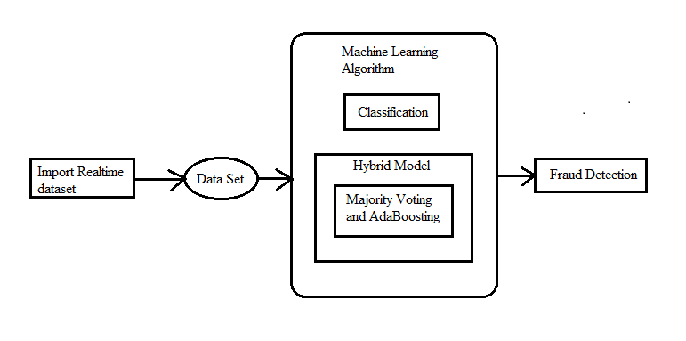

**Existing System**

* + Three methods to detect fraud are presented. Firstly, clustering model is used to classify the legal and fraudulent transaction using data clusterization of regions of parameter value. Secondly, Gaussian mixture model is used to model the probability density of credit card user's past behavior so that the probability of current behavior can be calculated to detect any abnormalities from the past behavior. Lastly, Bayesian networks are used to describe the statistics of a particular user and the statistics of different fraud scenarios. The main task is to explore different views of the same problem and see what can be learned from the application of each different technique.

**Disadvantages**

* + There is no Majority Voting technique for credit card fraud detection.
  + There is no Machine Learning Techniques in the existing system.

**Proposed System**

Total of twelve machine learning algorithmsare used for detecting credit card fraud. The algorithmsrange from standard neural networks to deep learningmodels. They are evaluated using both benchmark and realworldcredit card data sets. In addition, the AdaBoost andmajority voting methods are applied for forming hybridmodels. To further evaluate the robustness and reliability ofthe models, noise is added to the real-world data set.

**Advantages:**

Thekey contribution of this paper is the evaluation of a varietyof machine learning models with a real-world credit carddata set for fraud detection.

**System Requirements**

**H/W System Configuration:-**

# Processor : Intel (R) Pentium (R)

Speed : 1.1 Ghz

RAM : 2GB

Hard Disk : 57 GB

Key Board : Standard Windows Keyboard

Mouse : Two or Three Button Mouse

Monitor : SVGA

# S/W System Configuration

* Operating System : Windows 7 /8
* Application Server : Tomcat5.0/6.X/8.X
* Front End : HTML, Java, Jsp
* Scripts : JavaScript.
* Server side Script : Java Server Pages.
* Database Connectivity : Mysql.
* Java Version : jdk 1.8